Present Value (PV)
The Present Value (PV) tells you what a future cash inflow is worth today, given a specific discount rate (here, 10%).
Because of inflation and opportunity cost, a rupee today is worth more than a rupee tomorrow.
We use this formula:
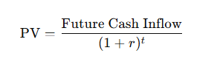
where:
- r = discount rate (10% = 0.10)
- t = year number
- Cash Inflow = amount expected that year

Example for Project A

Year 1
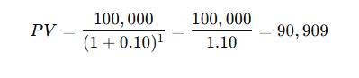
(round off → 90,900)

Year 2

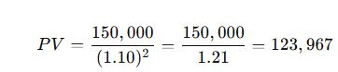
(round off → 123,900)

Year 3

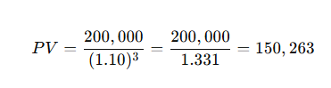
(round off → 150,200)

Year 4

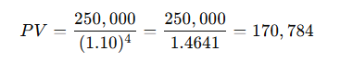
(round off → 170,750)

Year 5

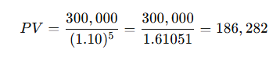
(round off → 186,300)
Now add them all:
PVtotal=90,900+123,900+150,200+170,750+186,300=722,050PV_{\text{total}} = 90,900 + 123,900 + 150,200 + 170,750 + 186,300 = 722,050PVtotal​=90,900+123,900+150,200+170,750+186,300=722,050
Total PV of inflows (Project A) = Rs. 722,050

